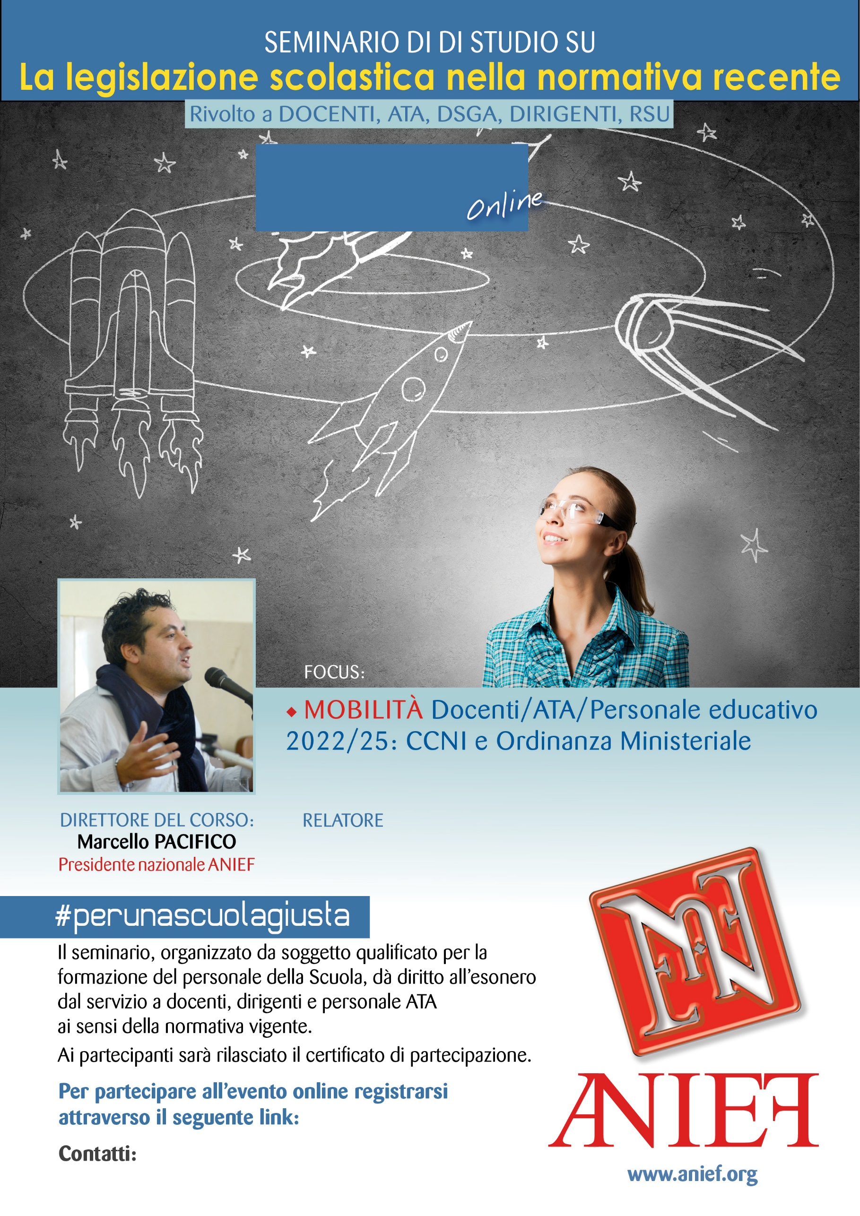

LINK DIRETTA: https://anief.org/as/WL16

reggio-calabria@anief.net

MARIA DANIELA MAUCERI

REGGIO CALABRIA

07/03/2022 ORE 08:00 – 10:00